Join us for
Refreshments and a Live Auction to support the Scholarship Program!
Grand Ballroom
Chula Vista Resort
Tuesday, June 6, 2023 starting at 5:30pm
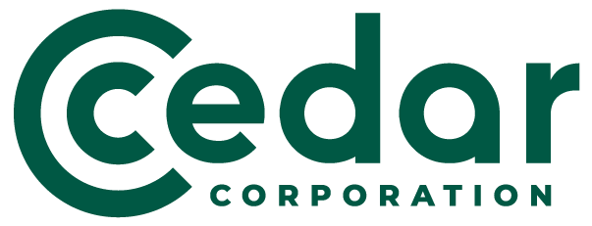Sponsored by:
The Wisconsin County Highway Association (WCHA) Scholarship Program will be holding a fundraiser at their Winter Road School for their 3 types of scholarships (civil engineering, transportation field and professional development). The WCHA will be holding a live auction and would like to collect auction items from businesses across each section of the state. 100% of the money raised will go towards the scholarships.
We are asking Counties and Businesses to donate an item of approximately $50 value and will recognize each business during the time their item is being auctioned. NOTE: Local items raise the most money! Try to think of personalized items from your region, if possible!

Thanks again for your support!
Any questions or concerns regarding the auction or our scholarship program, please contact me at the following information.
Gary L. Kennedy, WCHA Professional Development Director
1355 N 16th Street
Manitowoc, WI 54220
920-323-6500 or gkennedy@wiscohwy.org

